Citizenship, Economics and Society (Secondary 1-3)
“3-minute Concept” Animated Video Clips Series:
“Global Citizenship”
Teaching Guidelines

1. Title of the animated video clip: “Global Citizenship”
2. Duration of the animated video clip: Around 3 minutes
3. Related CES Module: Module 3.4 The World in Response to Global Issues
4. Introduction of the animated video clip: The animated video clip was developed by the Personal, Social and Humanities Education Section, Curriculum Development Institute, Education Bureau. It uses daily examples and simple language to succinctly explain the concept of “Global Citizenship”.
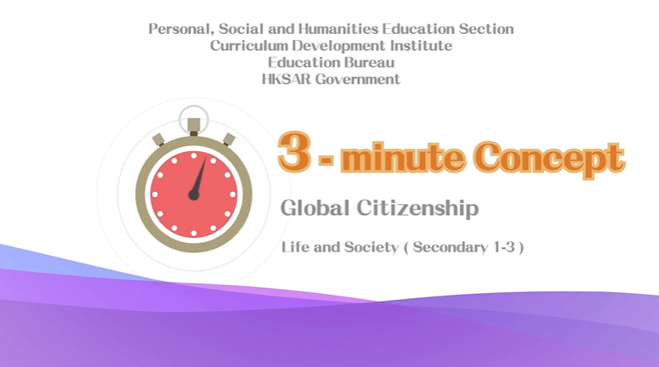
Citizenship, Economics and Society (Secondary 1-3)
Video link:
https://emm.edcity.hk/media/Life+and+Society+%223-minute+Concept%22+Animated+Video+Clips+SeriesA+%285%29+Global+Citizenship+%28English+subtitles+available%29/1_42yb2brr
5. Teaching tips: Teachers must explain the following main points to students after playing the “Global Citizenship” animated video clip:
1) Development of consciousness and quality of global citizenship begins with the understanding of local, national and global topics | Teachers should point out to students that cultivating interest and concern for local, national and global topics and understanding the connections and interdependencies between different parts of the world are important in developing consciousness and quality of global citizenship. Teachers can guide students to develop interest and concern for local, national and global topics and learn to understand social phenomena from different perspectives objectively and impartially to broaden their global perspective.
2) Maintain a positive and appreciative attitude and respect conditions of different countries | Teachers should point out to students that as different countries in the world have different levels of development in culture, history and socio-economic aspects, they need to respect the conditions of different countries when they study global topics. They should always maintain a positive and appreciative attitude in understanding the uniqueness of different countries. A country should not impose its policies and values on other countries, but should treat the conditions of other countries with tolerance and mutual respect.
3) Reflect more on the role and responsibility of oneself as member of the global community | Teachers need to point out to students that as relations between countries in the world are complex and thus are world topics. They should not make rash judgements and comments on the conditions of individual countries. Teachers should further point out to students that expressing concern for global topics is not equivalent to criticising and laying blame. Students should reflect more on their roles and responsibilities as members of the global community, develop a broad perspective, adopt a positive and responsible attitude in understanding global topics and develop consciousness and quality of global citizenship.
4) Use appropriate channels to express care for society | Teachers need to point out to students that Hong Kong is a free and open society with a wide range of channels for people to express their views. Teachers should further explain to students that responsible citizens are always concerned with the well-being of society and know the appropriate ways to express their concern for society (e.g., by participating in voluntary services to serve the community).
5) Select credible information to develop consciousness and quality of global citizenship | Teachers should point out to students that with the increasing popularity of the Internet, they can easily access abundant information from different online sources, such as social media. Teachers should remind students to be aware of the authenticity of the information and not to trust unverified information on the Internet easily. Do not forward posts and information before confirming their authenticity to avoid violating the law inadvertently. At the same time, teachers should further point out that students should make more reference to credible information (e.g., information and data provided by official bodies and credible organisations) and adopt an objective and rational attitude in understanding the conditions of different countries to develop consciousness and quality of global citizenship.

6. Consolidation questions: (See next page)

“3-minute Concept” Animated Video Clips Series:

“Global Citizenship”

Worksheet

A. Fill-in-the-blank Questions
Put the correct answer in the space provided.

The qualities of global citizens include:

B. True or False
Study the following sentences about “Global Citizenship”. Put a “T” in the blank for correct description and an “F” for incorrect description.
 | “Global citizens” are concerned with topics such as gender equality, global wealth disparity, global refugee crisis, cultural heritage conservation, climate change, food safety, etc. | T
 | People are impressed by the effort shown by the girl in the video who raised money to buy mosquito nets for people in Africa. | T
 | “Global citizens” only care about non-local issues happening in places around the world, but not issues happening in local society. | F

C. Short Question

In face of the challenges that threaten the well-being of humankind, what actions can global citizens take?
Global citizens can provide direct aid for people in need, provide
coordination for voluntary work, relay educational messages to
other people and work collaboratively with them in order to fulfil
the mission of global citizens.

The End

